Tangent-Radius Theorem
# Source: AI Source: Provided by: [Data Path: Persons Table -> ID Column: 1, Name_En Column: Motasem Essam] -> From: [ChatGPT] on [7/25/2026]
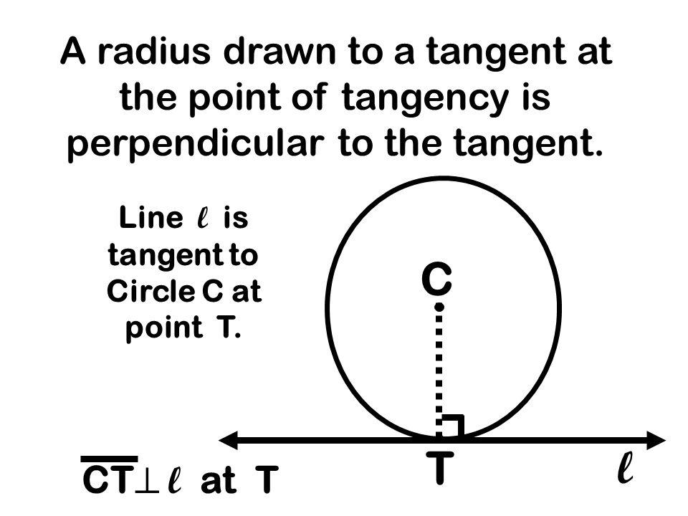
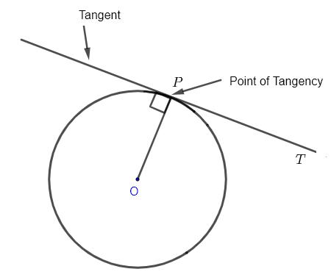
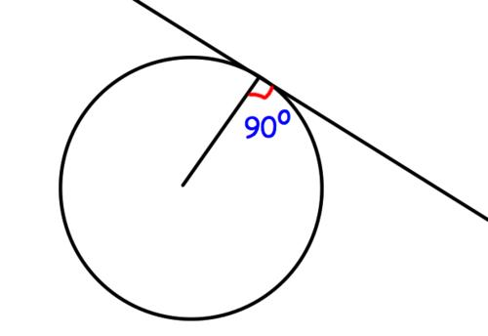
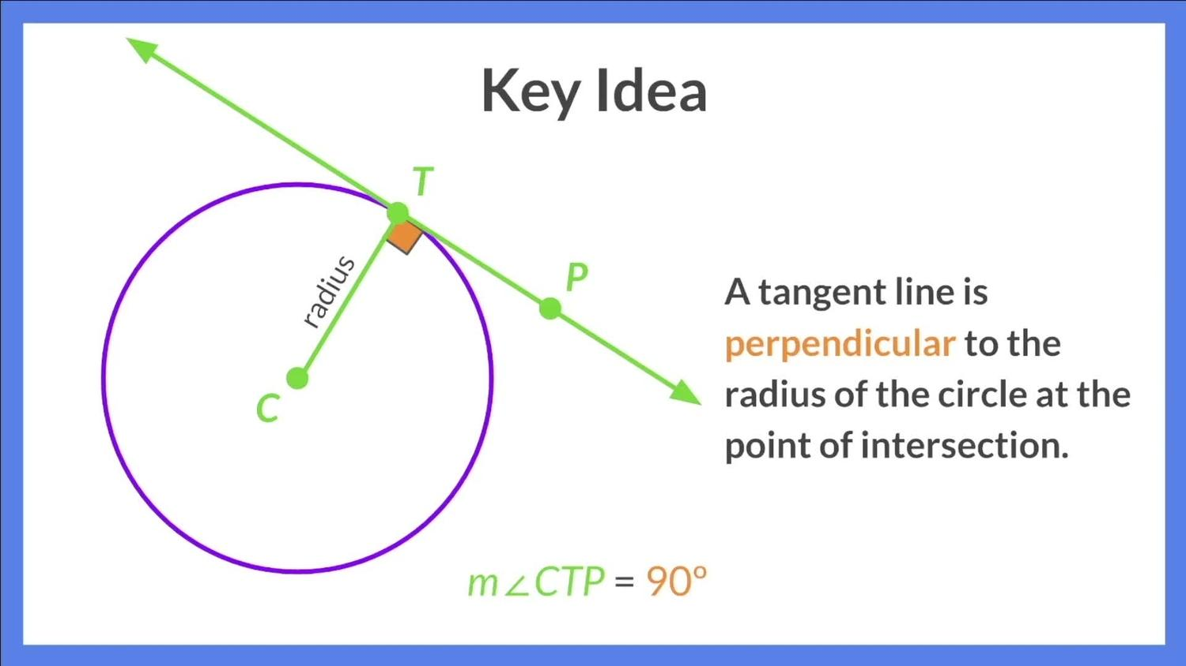
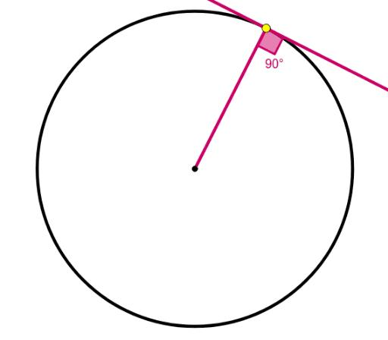

Definition
# Source: AI Source: Provided by: [Data Path: Persons Table -> ID Column: 1, Name_En Column: Motasem Essam] -> From: [ChatGPT] on [7/25/2026]
The Tangent–Radius Theorem states that the radius drawn from the center of a circle to the point of tangency is perpendicular to the tangent line.
If a line $l$is tangent to a circle at $T$, and $O$is the center of the circle, then:
$$\boxed{OT⊥l}$$
Therefore, the angle between the radius and the tangent at the point of tangency is:
$$\boxed{{90}^{∘}}$$

Theorem Statement
# Source: AI Source: Provided by: [Data Path: Persons Table -> ID Column: 1, Name_En Column: Motasem Essam] -> From: [ChatGPT] on [7/25/2026]
Let $l$be tangent to a circle with center $O$at $T$.
Then:
$$\boxed{OT⊥l}$$
or equivalently:
$$\boxed{m\left(∠OTL\right)={90}^{∘}}$$
where $L$is any point on the tangent line other than $T$.

Fundamental Concept
# Source: AI Source: Provided by: [Data Path: Persons Table -> ID Column: 1, Name_En Column: Motasem Essam] -> From: [ChatGPT] on [7/25/2026]
A tangent line touches a circle at exactly one point.
The radius connecting the center to that point of contact always forms a right angle with the tangent.
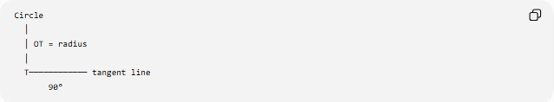
Circle
│
│ OT = radius
│
T──────────── tangent line
90°
Thus:
$$\boxed{\text{Radius to point of tangency}⊥\text{Tangent}}$$
This is one of the fundamental relationships between a circle and its tangent.

Main Parts
# Source: AI Source: Provided by: [Data Path: Persons Table -> ID Column: 1, Name_En Column: Motasem Essam] -> From: [ChatGPT] on [7/25/2026]
For a circle with center $O$:
- $O$= center
- $T$= point of tangency
- $OT$= radius
- $l$= tangent line
- $OT⊥l$
- $OT=r$
Therefore:
$$\boxed{m∠OTL={90}^{∘}}$$

Converse of the Theorem
# Source: AI Source: Provided by: [Data Path: Persons Table -> ID Column: 1, Name_En Column: Motasem Essam] -> From: [ChatGPT] on [7/25/2026]
The theorem also has a useful converse:
If a line through a point $T$on a circle is perpendicular to the radius $OT$, then that line is tangent to the circle at $T$.
Thus:
$$\boxed{OT⊥l⟹l\text{ is tangent at }T}$$
provided $T$lies on the circle.
So the perpendicular relationship can be used both to identify and construct a tangent.

Why the Theorem Is True
# Source: AI Source: Provided by: [Data Path: Persons Table -> ID Column: 1, Name_En Column: Motasem Essam] -> From: [ChatGPT] on [7/25/2026]
Suppose a line touches a circle at $T$, but the radius $OT$were not perpendicular to the tangent.
The perpendicular distance from $O$to the tangent would then be less than $OT=r$.
A line whose distance from the center is less than the radius intersects the circle at two points, meaning it would be a secant, not a tangent.
Therefore, for a line to touch the circle at exactly one point:
$$\boxed{d\left(O , l\right)=r}$$
and the shortest distance from a point to a line is perpendicular.
Hence:
$$\boxed{OT⊥l}$$

Tangent and Radius Relationship
# Source: AI Source: Provided by: [Data Path: Persons Table -> ID Column: 1, Name_En Column: Motasem Essam] -> From: [ChatGPT] on [7/25/2026]
The tangent–radius relationship can be summarized as:
$$\boxed{\text{Point of Tangency}→\text{Radius}⊥\text{Tangent}}$$
At the point of tangency:
$$\boxed{\text{Radius angle with tangent}={90}^{∘}}$$

Example 1 — Finding an Angle
# Source: AI Source: Provided by: [Data Path: Persons Table -> ID Column: 1, Name_En Column: Motasem Essam] -> From: [ChatGPT] on [7/25/2026]
Suppose $l$is tangent to a circle at $T$, and $O$is the center.
Find:
$$m\left(∠OTL\right)$$
By the Tangent–Radius Theorem:
$$OT⊥l$$
Therefore:
$$\boxed{m\left(∠OTL\right)={90}^{∘}}$$

Example 2 — Finding a Missing Angle
# Source: AI Source: Provided by: [Data Path: Persons Table -> ID Column: 1, Name_En Column: Motasem Essam] -> From: [ChatGPT] on [7/25/2026]
Suppose a triangle $OPT$is formed where:
- $OT$is a radius,
- $PT$is tangent,
- $OP=13$,
- $OT=5$.
Because:
$$OT⊥PT$$
triangle $OPT$is a right triangle.
Using the Pythagorean theorem:
$$OP^{2}=OT^{2}+PT^{2} \\ {13}^{2}=5^{2}+PT^{2} \\ 169=25+PT^{2} \\ PT^{2}=144 \\ \boxed{PT=12}$$

Tangent Length
# Source: AI Source: Provided by: [Data Path: Persons Table -> ID Column: 1, Name_En Column: Motasem Essam] -> From: [ChatGPT] on [7/25/2026]
The theorem creates a right triangle whenever an external point $P$, the center $O$, and the point of tangency $T$are connected.
Thus:
$$△POT$$
is a right triangle.
Therefore:
$$PO^{2}=PT^{2}+OT^{2}$$
Since:
$$OT=r$$
we obtain:
$$\boxed{PT=\sqrt{PO^{2}-r^{2}}}$$
This is the formula for the tangent length from an external point.

Two Tangents from the Same External Point
# Source: AI Source: Provided by: [Data Path: Persons Table -> ID Column: 1, Name_En Column: Motasem Essam] -> From: [ChatGPT] on [7/25/2026]
Suppose an external point $P$has two tangent segments touching the circle at $A$and $B$.
Then:
$$PA⊥OA$$
and:
$$PB⊥OB$$
Since:
$$OA=OB=r$$
the two right triangles are congruent.
Therefore:
$$\boxed{PA=PB}$$
This is known as the Equal Tangents Theorem.
So the Tangent–Radius Theorem provides the right-angle foundation for the equal-tangent relationship.

Tangent–Radius Theorem and Tangent–Chord Theorem
# Source: AI Source: Provided by: [Data Path: Persons Table -> ID Column: 1, Name_En Column: Motasem Essam] -> From: [ChatGPT] on [7/25/2026]
These are different theorems.
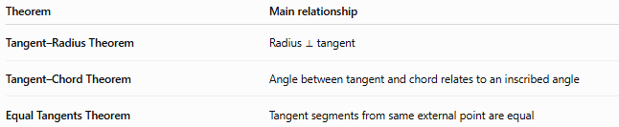
Theorem | Main relationship
Tangent–Radius Theorem | Radius ⟂ tangent
Tangent–Chord Theorem | Angle between tangent and chord relates to an inscribed angle
Equal Tangents Theorem | Tangent segments from same external point are equal
The Tangent–Radius Theorem is specifically about the radius and tangent at the point of contact.

Coordinate Geometry
# Source: AI Source: Provided by: [Data Path: Persons Table -> ID Column: 1, Name_En Column: Motasem Essam] -> From: [ChatGPT] on [7/25/2026]
For a circle:
$${\left(x-h\right)}^{2}+{\left(y-k\right)}^{2}=r^{2}$$
suppose $T=\left(x_{1} , y_{1}\right)$is a point on the circle.
The radius vector from $O=\left(h , k\right)$to $T$is:
$$\vec{OT}=\left(x_{1} , -h y_{1}-k\right)$$
A tangent line at $T$must be perpendicular to this radius.
Therefore, its normal vector is:
$$\boxed{\left(x_{1} , -h y_{1}-k\right)}$$
and the tangent equation is:
$$\boxed{\left(x_{1}-h\right)\left(x-x_{1}\right)+\left(y_{1}-k\right)\left(y-y_{1}\right)=0}$$
This equation is a direct coordinate-geometry application of the Tangent–Radius Theorem.

Example — Unit Circle
# Source: AI Source: Provided by: [Data Path: Persons Table -> ID Column: 1, Name_En Column: Motasem Essam] -> From: [ChatGPT] on [7/25/2026]
For the unit circle:
$$x^{2}+y^{2}=1$$
consider the point:
$$T=\left(x_{1} , y_{1}\right)$$
where:
$$x_{1}^{2}+y_{1}^{2}=1$$
The tangent at $T$is:
$$\boxed{x_{1}x+y_{1}y=1}$$
The radius $OT$is perpendicular to this tangent.

Classification
# Source: AI Source: Provided by: [Data Path: Persons Table -> ID Column: 1, Name_En Column: Motasem Essam] -> From: [ChatGPT] on [7/25/2026]
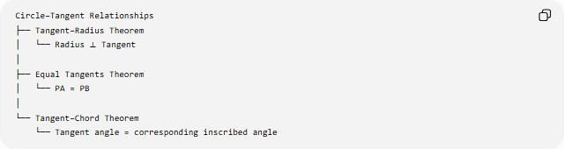
Circle–Tangent Relationships
├── Tangent–Radius Theorem
│ └── Radius ⟂ Tangent
│
├── Equal Tangents Theorem
│ └── PA = PB
│
└── Tangent–Chord Theorem
└── Tangent angle = corresponding inscribed angle

Important Properties
# Source: AI Source: Provided by: [Data Path: Persons Table -> ID Column: 1, Name_En Column: Motasem Essam] -> From: [ChatGPT] on [7/25/2026]
- The radius to the point of tangency is perpendicular to the tangent.
- The angle between the radius and tangent is:
$$\boxed{{90}^{∘}}$$
- The perpendicular distance from the center to the tangent equals the radius:
$$\boxed{d\left(O , l\right)=r}$$
- A line perpendicular to a radius at a point on the circle is tangent to the circle.
- The theorem creates a right triangle when an external point is connected to the center and point of tangency.
- It leads directly to the tangent-length formula:
$$\boxed{PT=\sqrt{PO^{2}-r^{2}}}$$
- It helps prove that tangent segments from the same external point are equal.

Applications
# Source: AI Source: Provided by: [Data Path: Persons Table -> ID Column: 1, Name_En Column: Motasem Essam] -> From: [ChatGPT] on [7/25/2026]
The Tangent–Radius Theorem is used in:
- Circle geometry
- Tangent problems
- Right-triangle calculations
- Tangent-length problems
- Equal tangent proofs
- Circle constructions
- Coordinate geometry
- CAD
- Engineering
- Computer graphics

Key Formula Summary
# Source: AI Source: Provided by: [Data Path: Persons Table -> ID Column: 1, Name_En Column: Motasem Essam] -> From: [ChatGPT] on [7/25/2026]
Main theorem
$$\boxed{OT⊥l}$$
Right angle
$$\boxed{∠OTL={90}^{∘}}$$
Distance from center to tangent
$$\boxed{d\left(O , l\right)=r}$$
Tangent length
$$\boxed{PT=\sqrt{PO^{2}-r^{2}}}$$
Equal tangents
$$\boxed{PA=PB}$$
when $PA$and $PB$are tangent segments from the same external point.

Conclusion
# Source: AI Source: Provided by: [Data Path: Persons Table -> ID Column: 1, Name_En Column: Motasem Essam] -> From: [ChatGPT] on [7/25/2026]
The Tangent–Radius Theorem states that the radius drawn to the point of tangency is perpendicular to the tangent line:
$$\boxed{OT⊥l}$$
Therefore, the tangent and radius form a ${90}^{∘}$angle. This simple relationship is fundamental to many other circle results, including tangent lengths, equal tangent segments, tangent constructions, and coordinate equations of tangent lines.

